Maximum marks for Assignment: _________6______ Assignment Declaration Date:____________
Assignment Submission Date (on or before):______________________________
Assignment assessment declaration Date by faculty (on or before):________________________
Question NO | Question Statement | Level of mapping and Number |  |  | Blooms Level | Marks
Question NO | Question Statement | CO | PO | PSO
Q1. | Define the term Quality. What is bug; defect, error & failure give an example of each? | CO1 | PO1 |  | 1 | 4
Q2 | Write short note on TQM | CO1 | PO1,PO2 |  | 2 | 4
Q3 | Explain the term Customer as a King. | CO1 | PO1,PO2 |  | 2 | 3
Q4 | List and explain Problem Solving Techniques. | CO1 | PO2,PO3 |  | 2 | 6
Q5 | Explain Problem solving Software Tools. | CO1 | PO1 |  | 3 | 4
Q.6 | Explain Software development process | CO1 | PO2,PO3 |  | 3 | 4
Q.7 | Identify problematic area of SDLC | CO1 | PO4 |  | 4 | 4
Q.8 | Describe Pillars of Quality Management System | CO1 | PO1 |  | 2 | 4
Q.9 | List down characteristics of Software. | CO1 | PO1,PO2 |  | 1 | 4
Q.10 | Define constraints of software Product quality Assessment | CO1 | PO4,PO5,  PO11 |  | 3 | 6
Q.11 | Differentiate between software tools and techniques | CO1 | PO4 |  | 3 | 4
Q.12 | What is bug tracking, bug fixing & bug verification | CO1 | PO4 |  | 4 | 4
Q.13 | What is software testing process? Why do we have to test the software? Explain the reasons with respect to quality view, financial aspect, customer’s suppliers and process. | CO1 | PO1 |  | 2 | 6
Q.14 | What is software quality? what is mean by quality attribute of the software? Explain continual improvement cycle with neat labeled diagram of plan-Docheck-Act (PDCA) framework | CO1 | PO1 |  | 2 | 6
Blooms level no | Blooms Taxonomy terms
6 | 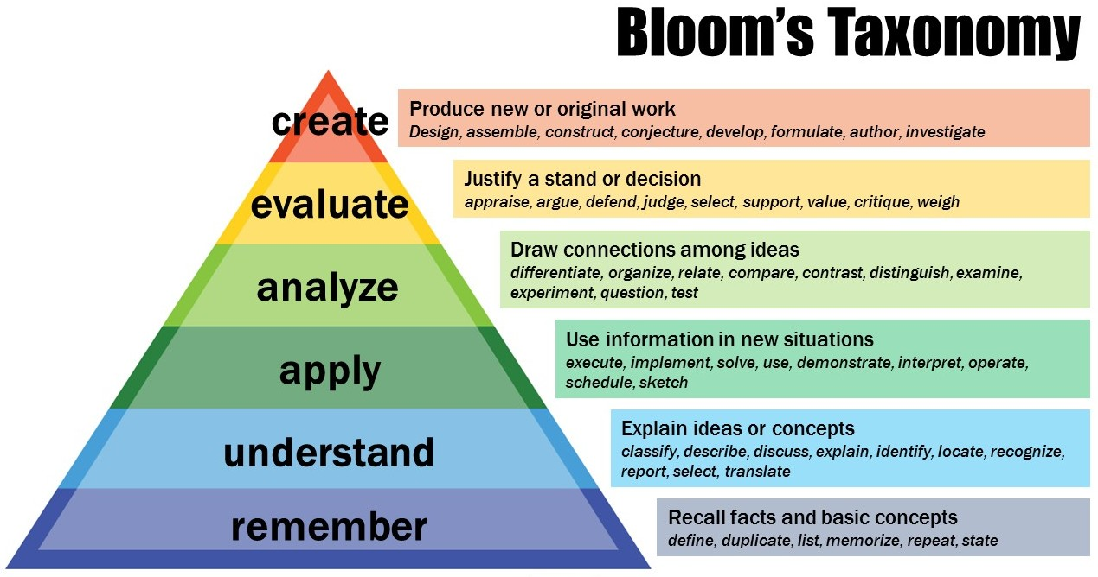
5
4
3
2
1

Subject In-charge HOD

